A000-Asia-Thailand-Ban Chiang-Ceramic bottle-2100 BCE

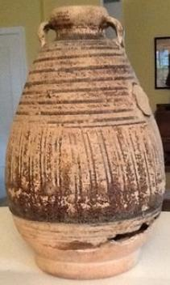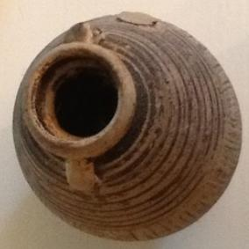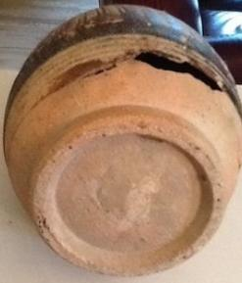

Figs. 1-3. Thailand-Ban Chiang-Ceramic bottle-2100 BCE

Case No.: 5

Accession No.

Formal Label: Thailand-Ban Chiang-Ceramic bottle-2100 BCE

LC Classification: DS589.B17

Display Description: This Ban Chiang Ceramic bottlemay date to the earliest grave 2100 BCE, as evidenced by associated grave crucibles and bronze fragments. Bronze objects included bracelets, rings, anklets, wires and rods, spearheads, axes and adzes, hooks, blades, and little bells.

Date or Time Horizon: 2100 BCE

Geographical Area: Ban Chiang, Udon Thani, Thailand

Map:

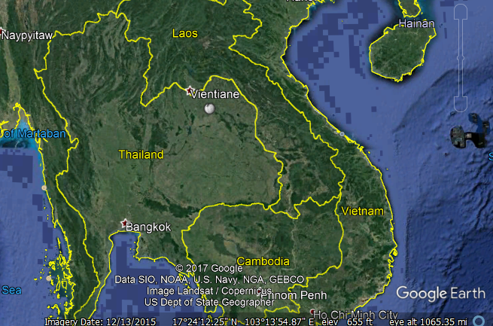

Fig. 4. Ban Chiang is near the white solid circular marker SE of Vientiane.

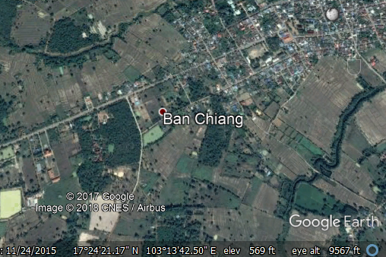

Fig. 5. Detail of Ban Chiang location.

GPS coordinates: [17°24′25″N 103°14′29″E](https://tools.wmflabs.org/geohack/geohack.php?pagename=Ban_Chiang&params=17.4069_N_103.2414_E_type:landmark_region:TH-41)

Cultural Affiliation: Ban Chiang

Medium: Ceramic

Dimensions: 6 1/2" tall and 4" wide at hip

Weight:

Condition: original

Provenance: Thailand

Discussion:

A Neoilithic date of 2100 BCE was obtained from rice phytoliths from inside a grave vessel of the lowest grave at Ban Chiang. A dating program for this site has involved dating the bones from the people who lived at Ban Chiang and the bones of animals interred with them. The resulting determinations have been analyzed using the Bayesian statistic OxCal 4.0. The results suggest that the initial Bronze Age settlement of Ban Chiang took place by c 1500 BCE and continued to about 1000 BCE (White 2008).

References:

Higham, Charles. 1998. *Prehistoric Thailand*. River Books; 1st Edition edition.

Higham C.F.W. and T.F.G. Higham 2009. “A new chronological framework for prehistoric Southeast Asia, based on a Bayesian model from Ban Non Wat,” *Antiquity* 82:1-20.

Higham C.F.W. 2011. The Bronze Age of Southeast Asia: new insight on social change from Ban Non Wat. *Cambridge Archaeological Journal* 21(3): 365-89

Higham C.F.W., R. Ciarla, T.F.G. Higham, A. Kijngam and F. Rispoli. 2011. “The establishment of the Bronze Age in Southeast Asia,” *Journal of World Prehistory* 24 (4),227-274:

Higham C.F.W., T.F.G. Higham and A. Kijngam. 2011. “Cutting a Gordian Knot: The Bronze Age of Southeast Asia, timing, origins and impact,” *Antiquity* 85:583-98.

Pietrusewsky, Michael; Douglas, Michele T. (Michele Toomay) 2001. ["Intensification of Agriculture at Ban Chiang: Is There Evidence from the Skeletons?"](http://muse.jhu.edu/login?uri=/journals/asian_perspectives/v040/40.2pietrusewsky.pdf) (PDF). [Asian Perspectives](https://en.wikipedia.org/wiki/Asian_Perspectives). [Project MUSE](https://en.wikipedia.org/wiki/Project_MUSE): [University of Hawai'i Press](https://en.wikipedia.org/wiki/University_of_Hawai%27i_Press). 40 (2): 157–178. [doi](https://en.wikipedia.org/wiki/Digital_object_identifier):[10.1353/asi.2001.0023](https://doi.org/10.1353%2Fasi.2001.0023). [eISSN](https://en.wikipedia.org/wiki/International_Standard_Serial_Number#Electronic_ISSN) [1535-8283](https://www.worldcat.org/issn/1535-8283). [ISSN](https://en.wikipedia.org/wiki/International_Standard_Serial_Number) [0066-8435](https://www.worldcat.org/issn/0066-8435)..

White, J.C. and Hamilton, E. G. 2009. “The Transmission of Early Bronze Technology to Thailand: New Perspectives,” *World Prehistory* 22: 357–397

White, J.C. 2008 “Dating Early Bronze at Ban Chiang, Thailand.” In *From Homo erectus to the Living Traditions*. Pautreau, J.-P.; Coupey, A.-S.; Zeitoun, V.; Rambault, E., editors. European Association of Southeast Asian Archaeologists, Chiang Mai, pp. 91-104.

White, J. C. 1995. “Incorporating Heterarchy into Theory on Socio‐political Development: The Case from Southeast Asia,” *Archeological Papers of the American Anthropological Association*, 6(1), 101-123.

Aprox. 6 1/2" tall and 4" wide at hip